PROJECT – REPORT
RDBMS Lab Project

COLLEGE AUTOMATION SYSTEM

Submitted To:

Dr. Gurjit Singh Bhathal
Submitted by:
Shanti Kumari – 11701168
Daljeet Kaur - 11701170
Batch: 3CE5
ABSTRACT

This report introduces the management system which is designed to automate the entire operations of a college and in reducing time in activities using centralized data handling and paperless work with reduced manpower. This Desktop Application has functionality that is basic requirement for college staff. It will help the college staff to access the application and keep record of college data like Student, their marks details and attendance etc. This general application is planned for aiding the students about details on the Courses, Subjects, Marks, Attendance.

INTRODUCTION

1.1 INTRODUCTION TO PROJECT
Presently, each and every day, a novel application or software is being introduced in the economy that serves to enhance and uplift the lifestyle of the people in innumerable ways. College Automation System (CAS) is an application which aims to make the work load of college staff less.
CAS is a Desktop Application. Users have better experience with desktop application as compared to Web applications. CAS provides basic functionality to the users (in this case teachers) to maintain the records of the students. After login the user is redirected to the home page.
The homepage or gateway displays a tree-view of the students according to their session, course. The gateway also consist of a menubar which can be used to navigate to different pages in the application like New Registration, View Students, Add marks, update marks, view marks, Mark attendance etc.
New registrations can be made through the New Registration Form, user have to enter all the required details of the student and the student’s details will be added to the database. The students can be enrolled to different semesters by using the Semester Registration Page. All the details of already saved students can be accessed by the View Students Page.
Teachers can add or update or view the marks of the students using the Add/Update/View Page. The teacher has to enter the session, course and semester and the students who fall into these conditions will be displayed in a tree-view. Teacher can select any student and click on the add marks button to add the marks of the student. If the marks of that particular student has been already added, the teacher will be redirected to the update marks page where they can update the marks of the student. There also a view button which displays the entered marks of the students, total marks obtained and percentage of the student.
CAS also provides the functionality of marking attendance of the students and maintain the record of the same. The teachers can marks the attendance from the mark attendance page which can be accessed through the submenu of the Attendance. Students present in selected session, course and semester will be displayed. If the student is present checkbox will be checked else it will be left unchecked. The record of the attendance can also be viewed through the view attendance page.
CAS also provide a master records which can be used to add a new session or new course or a new subject to the database. Already present sessions, courses and subjects can also be viewed and deleted. Masters records also provides Semester Subject Page which can be used to add different subjects to different semesters.
The project is easy to use and has a friendly user interface so anyone with basic knowledge of computers can use the website and get benefited. Hence, the motto “Education must be accessible to anyone anytime and everywhere” is fulfilled.

1.2 PROJECT CATEGORY
The project presented in this paper belongs to the “Desktop Applications”. The simplest for a desktop application can be:
it runs on a PC operating system (Windows, Mac, Linux, etc.)
it has a graphical user interface
it does not run inside a web browser.
An Internet connection is not required to run to this application.
The application is developed in Python using Tkinter framework. This kind of application contains different forms and widgets. A python desktop application can be deployed as exe file. An EXE file contains an executable program for Windows. EXE is short for "executable," and it is the standard file extension used by Windows programs.

1.3 PROBLEM FORMULATION
Teachers have to maintain records of every student on paper which leads to huge paper work. Sometimes, it is hard to find record of some student through huge pile of papers. The idea mainly focuses on making the reducing the workload of teachers by using centralized database from where every teacher has access to the records and they can add, update or remove information.

1.4 EXISTING SYSTEMS
Currently, teachers maintain records on papers. Different information is stored in different registers etc. For marks, there is different register or papers, for attendance there is different. This makes the job more time consuming to maintain records at different places. Further, it is difficult to find records of students. Sometimes, if some information of student say contact number is changed, is has to be updated everywhere where contact number of the student is written. Again, this is very tedious task, finding where contact number is stored and updating it.

1.5 PROPOSED SYSTEM
The current scenario presented a few major issues which are resolved in the proposed system. These include:
- This system reduces the paperwork. Records can be maintained in different pages of the application. It is less time consuming. It reduces the after work of maintaining record liking compiling marks of students. In this system, with a click of button it is possible.
- Besides, reducing paperwork it also reduces the efforts to find the records of students. Records of present students or existing student can be found by entering their registration id.
- If some detail of student is to be updated, it can be easily done and we done have to update it manually everywhere, the system will do it itself.
- The proposed system works on centralised database which means every teacher can access the data of students.
- The system interface is very user friendly, anyone can use this who has basic knowledge of English and computer and take the maximum benefit.

SYSTEM DESIGN

DESIGN APPROACH
Object Oriented Approach has been followed throughout the development of the project. Object oriented design works around the entities and their characteristics instead of functions involved in the software system. This design strategies focuses on entities and its characteristics. The whole concept of software solution revolves around the engaged entities.
The important concepts of Object Oriented Design:

• Objects - All entities involved in the solution design are known as objects. For example, person, banks, company and customers are treated as objects. Every entity has some attributes associated to it and has some methods to perform on the attributes.
• Classes - A class is a generalized description of an object. An object is an instance of a class. Class defines all the attributes, which an object can have and methods, which defines the functionality of the object.
In the solution design, attributes are stored as variables and functionalities are defined by means of methods or procedures.
• Encapsulation - In OOD, the attributes (data variables) and methods (operation on the data) are bundled together is called encapsulation. Encapsulation not only bundles important information of an object together, but also restricts access of the data and methods from the outside world. This is called information hiding.
• Inheritance - OOD allows similar classes to stack up in hierarchical manner where the lower or sub-classes can import, implement and re-use allowed variables and methods from their immediate super classes. This property of OOD is known as inheritance. This makes it easier to define specific class and to create generalized classes from specific ones.
• Polymorphism - OOD languages provide a mechanism where methods performing similar tasks but vary in arguments, can be assigned same name. This is called polymorphism, which allows a single interface performing tasks for different types. Depending upon how the function is invoked, respective portion of the code gets executed.
DATABASE DESIGN

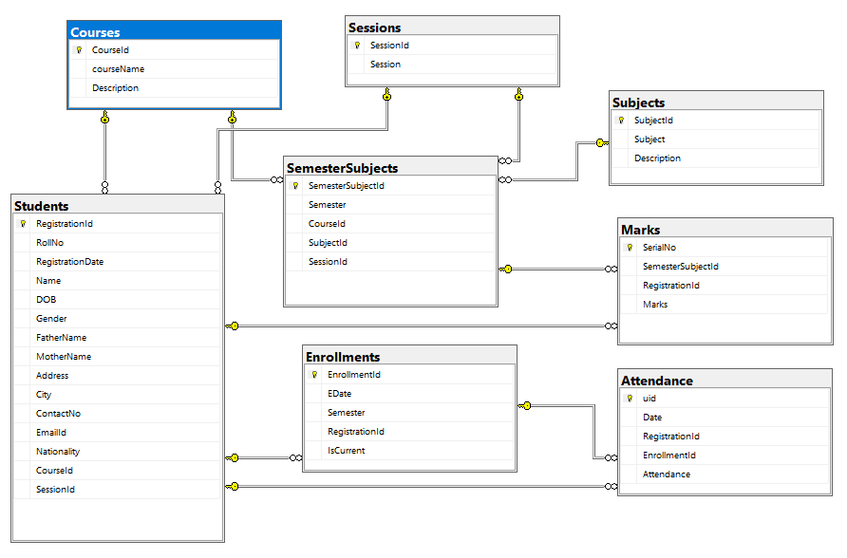

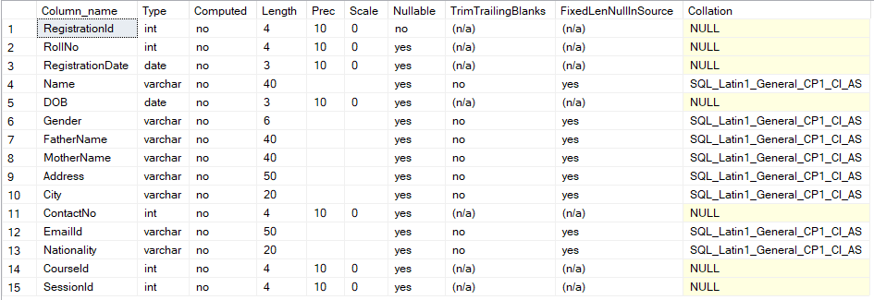
Student Table

Course Table

Session Table

Subject Table

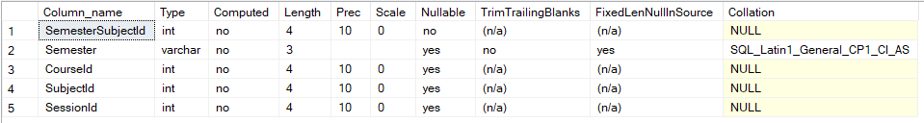
Semester Subject Table

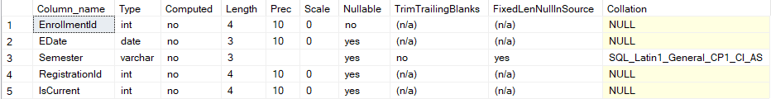
Enrollments Table

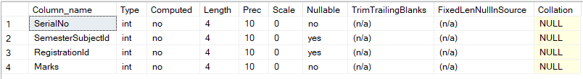
Marks Table

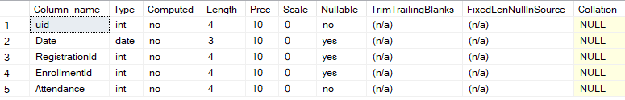
Attendance Table

Software Requirements:

- Python : Python is an in high-level, interpreted, interactive and object-oriented programming language programming language. Python is designed to be highly readable. Python offers much more structure and support for large programs. Created by Guido van Rossum and first released in 1991. Board standard library .Python has a huge library that contains reusable code. The huge library helps the developer to develop application in less time. Python’s bulk of the library is portable and cross-platform. It is compatible on UNIX, Windows, and Macintosh.
Python language can be used to create different types of applications: Console, Web, Desktop, Enterprise etc.

- Tkinter: Tkinter is Python’s de-facto standard GUI(Graphical User Interface) package. It is a thin object-oriented layer on top of Tcl/Tk. Tkinter is not the only Gui Programming toolkit for Python. It is however the most commonly used one.
- Pyodbc: pyodbc is an open source Python module that makes accessing ODBC databases simple. It implements the DB API 2.0 specification but is packed with even more Pythonic convenience.

- IDE
Spyder is a powerful scientific environment written in Python, for Python. It offers a unique combination of the advanced editing, analysis, debugging, and profiling functionality of a comprehensive development tool with the data exploration, interactive execution, deep inspection, and beautiful visualization capabilities of a scientific package.
Beyond its many built-in features, its abilities can be extended even further via its plugin system and API. Furthermore, Spyder can also be used as a PyQt5 extension library, allowing developers to build upon its functionality and embed its components, such as the interactive console, in their own PyQt software.

- Database
Microsoft SQL Server
Snapshots

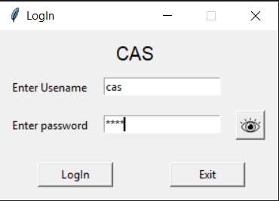

Login Page

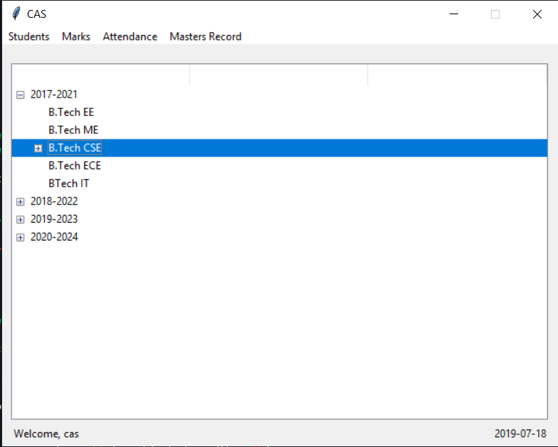
Homepage

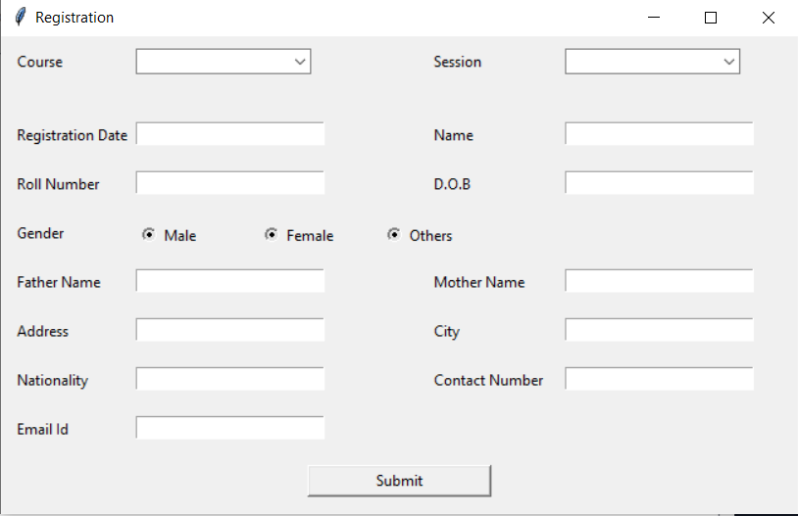
New Registration

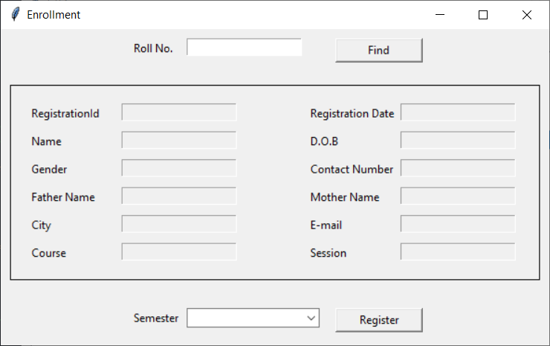
Semester Registration or Enrollment

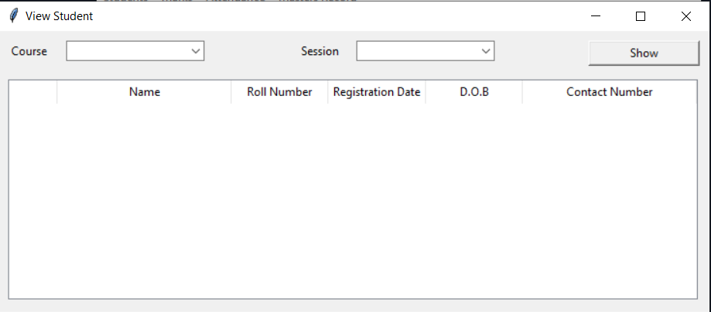
View Students

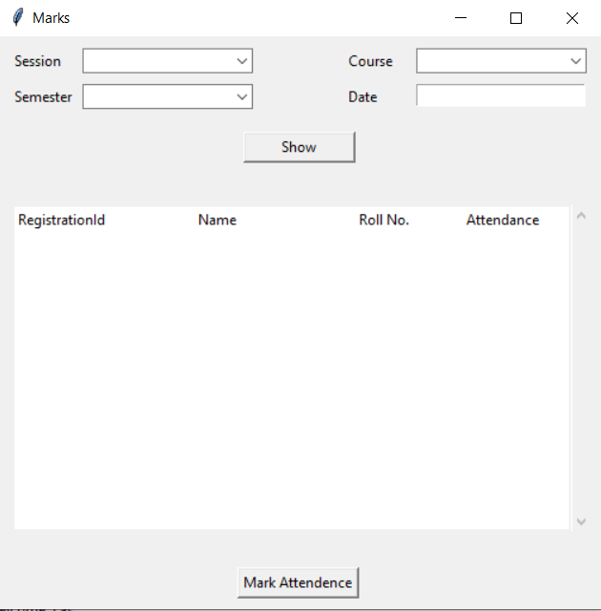
Mark Attendance

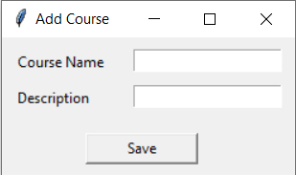
Masters – Add Course

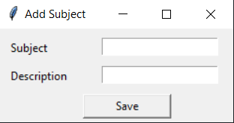
Masters – Add Subject

Conclusion

We have proposed a application which can help the teachers to reduce their work load. If teachers are busy in dealing with records, they might not able to give time to the students. This application will automate the things which teachers had to do manually. They do not have to sit all day and deal with lot of papers, there work will be done in just few clicks.
Our long term goal is to add more functionality to the current application and automate more functions, so paper work will be reduced to zero and will help the teachers.

